Magnetite/Reduced Graphene Oxide Synthesis and Study as a Potential Adsorbent for Absorptive Removal of Heavy Metals

Sherif F. T. Eldamhogy1*, Sabry A. Elkorashy 1, Hesham R. Tantawy2, Nadia F. Abd El-Aal 1

1 Chemistry Department, Faculty of Science, Suez Canal University, Ismailia 41522, Egypt

2 Chemical engineering department, Military Technical college

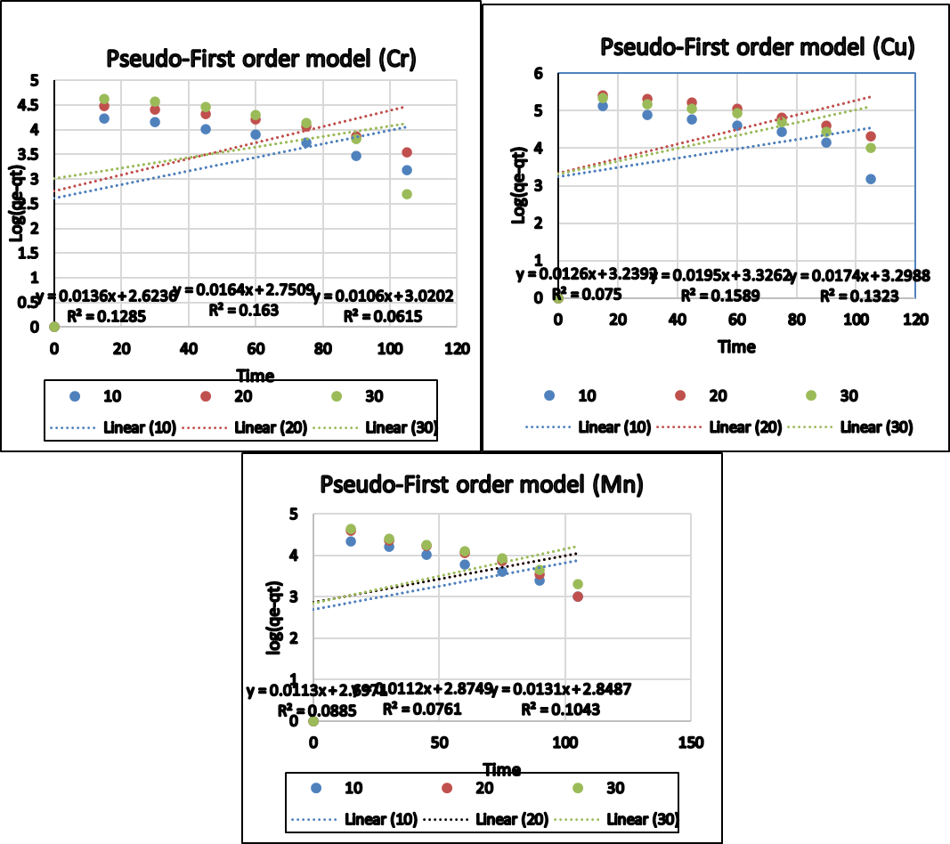

**Figure 1S.** Kinetics plots for linear fitting of data obtained from pseudo-first-order reaction model for: Cr (VI), Cu (II)& Mn (VII)

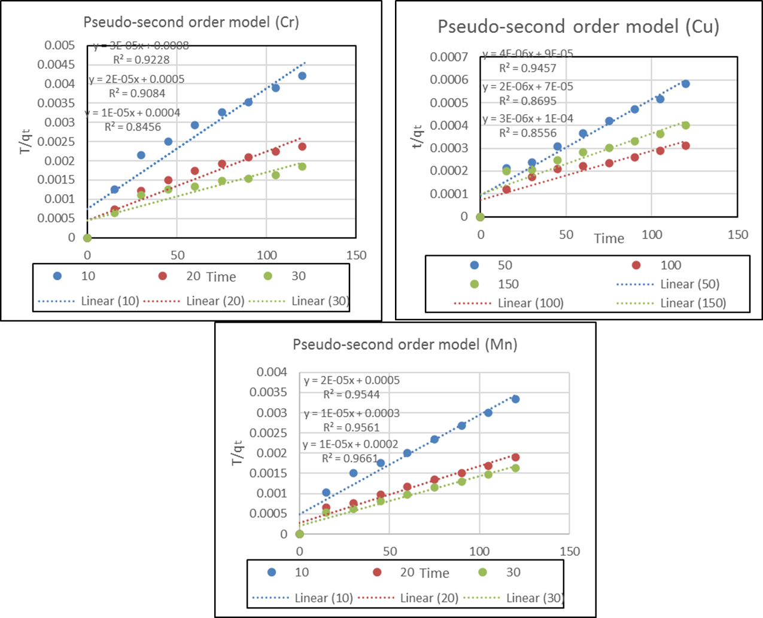

**Figure 2S.** Kinetics plots for linear fitting of data obtained from pseudo-second-order reaction model for:Cr (VI), Cu (II)& Mn (VII)