**Preparation of humic acid**

Extraction of humic substances was run according to Sanchez – Monedero et al [12]. A mixture of 40 g of the compost and 800 ml of 0.5N NaOH shaken for 12 hours then centrifuged for 15 minutes at 6000 rpm and the supernatant removed. The pH of supernatant adjusted to 2.0 or slightly less by addition of 2 M HCl. The formed precipitate of humic acid (HA) was allowed to coagulate for 24 hours at 4 oC, then separated from the soluble fulvic acid, and was centrifuged for 15 minutes at 6000 rmp. The coagulated precipitate was washed twice with 0.1 M HCl and then with deionized water, one part of HA was freeze-dried for storage (unpurified humic acid).

The precipitated humic acid washed several times with cold 0.05 N HCl until the filtrate became colorless. The humic acid re-dissolved in a small amount of 0.5 N NaOH solution, and then filtrate it to remove the residual. It precipitated again by acidification to pH 1.0 and washed several times for removing Cl- then humic was air-dried. In order to reduce the ash content of the purified humic acid and to increase its purity, the humic acids solution was treated with 0.5 % HCI-HF solution (5 ml HCI and 5 ml HF per liter) for 36 hours at room temperature [12]. The suspension centrifuged for 15 minutes at 6000 rpm to collect the precipitate. The precipitate was washed twice with 0.1 M HCI and one time with deionized water and was transferred to Petri dishes and dried at room temperature.

**Preparation of biochar**

Biochar produced from pyrolysis process of tomato residual. Pyrolysis performed in limited oxygen at temperature at 300 oC using a biochar machine. Biochar grounded to a fine powder with uniform size of the sifted flour using a sieve of 200 mesh sieves.

**Preparation of nanosilica**

Nanosilica has been prepared from rice husk. First, rice husk washed by warm deionised water. Pure silica was extracted by refluxing the washed rice husk with 6 N HCI for 4h [13]. The silica produced was washed several times using deionized water then it was burnt at 700oC for 3h in muffle furnace Stuart Scientific as shown in **Fig. S1.**

### Effect of adsorbent dose

The effect of adsorbent dosage on the adsorption of methylene blue dye was studied. In order to find out the optimum adsorbent dose, 30, 50, 100, 200 and 300 mg of adsorbent were added to five vials contains 10 mL of MB dye solution at pH 7. The mixtures were placed in Shaking Water Bath at constant temperature at 25°C for 120 min. the concentration of the pollutants was measured and a relation between adsorbent doses and concentration was constructed to detect the optimum dose.

### Effect of concentration

Effect of initial concentration of MB dye, 50 mg of adsorbents was added to a number of vials contains 10 ml of different concentrations of MB dye solution (75-200 mg/L), under room temperature (25oC) and pH 7 for 120 min.

### Effect of pH

Effect of pH on adsorption of MB was investigated in the pH range 2.5-12. 50 mg adsorbents samples were added to 10 ml of MB dye solutions with concentration 100 mg/L. The mixtures were placed in Shaker at room temperature (25°C) for 120 min.

### Effect of contact time

The adsorption of MB dye on the adsorbent was studied as a function of shaking time at 25 oC. A sample of 10 mL of MB dye (100 mg/L) solution at pH 7 was taken in a volumetric flask and shaken with 50 mg of adsorbent.

### Effect of temperature

50 mg adsorbent samples were added to 10 mL of methylene blue dye solutions with concentration 100 mg/L at pH 7. Each mixture was placed in Shaker at desired temperature (the range was 25-50°C) for 120 min.

## **Adsorption capacity**

### Effect of amount of adsorbent

Removal of MB by HBS was increase with increase amount of adsorbent. Removal of MB dye increase by HBS has removal efficiency of MB dye was from 96.62% when dose was 30 mg to 99.95% for 300 mg as shown in **Fig. (6)**.

The increment in adsorption effectiveness was a result of the increased number of adsorption sites [29]. Therefore, removal efficiency became in equilibrium with the amount of 300 mg of adsorbent within the specified parameters.

### Effect of pH on adsorption

It is known that our composite negatively charged from the zeta potential results, so it highly attracted the positively charged MB till pH 9. Below this pH value, the composite become positively charged i.e its adsorption capacity decrease. The pHpzc value is the point at which functional surface groups don't add to the solution's pH. The surface charge is negative above this pH value and the adsorbent takes on cations with higher affinity. As illustrated by [30] one of the key factors affecting pollutant adsorption of water is the pH of the solution. With a lower pH level, it is possible to increase the removal rate of contaminants by raising the solution pH, pollutant removal rate decreased if solution pH reached the optimal value. This might to be associated with the steady saturation of the active adsorption sites, and the electrostatic repulsion between the ions. These results agreed with [31] who illustrated that the initial concentrations MB were totally removed. On the other hand, further increase in metal ions concentrations decreases its removal efficiency. This fact can be related to that the pore sizes of the composite have been completely filled at higher concentration.

To estimate the pH effect on the adsorption capability of HBS, the adsorption experiments were done in solutions with different pH values. Figure present the pH effect on the uptake of MB from its aqueous solution by HBS. Results demonstrate an increase of MB uptake as the pH increased [32]. The uptake attained its extreme at pH 9 for MB by equilibrating 50 mg of the nanocomposites with 10 ml of a 100 mg/L of MB solution for 2 h. Low absorption capability happens at lower pH, which may be due to protonation of the ligand nitrogen atoms as shown in **Fig. (7)**. Results demonstrate an increase of MB dye uptake as the pH increased. The uptake attained its extreme at pH 9. Low absorption capability happens at lower pH, which may be due to protonation of the ligand nitrogen atoms. At low pH, the detention of MB dye by composite is not considerable since the ligand is fully in its protonated state [33].

### Effect of contact time

The relationship between the contact time and removal efficiencies of 100 mg/L from MB adsorbed by HBS illustrated in **Fig. (8)** the bio-sorbent dose was 50 mg/10mL for MB.

The adsorption reached equilibrium within 5min for the initial concentrations, there after it became nearly constant. The percent of the metal ions and MB removed gradually with time increases, and reached its maximum level after 60 min.

This affinity related to the concept that, at the beginning of the adsorption large numbers of vacated surface sites are available but after lapse time the rest vacant surface areas are difficult to be occupied.

At the beginning of the adsorption process all reaction sites are vacant and therefore the degree of removal is high. After the initial rapid absorption, the absorption rate was very slow almost reaching a constant value [34].

### Effect of concentration

The effect of initial concentration on the removal efficiency of HBS was investigated over wide range of MB concentration keeping other conditions as adsorbent dose, volume of solution 10 mL and solution pH 7. The results are presented in **Fig. (9)**. It can be noticed from these figures that uptake of MB was rapid at lower concentration and as concentration increase the amount of MB adsorbed was decreased. At lower concentration 75 mg/L for MB, the ratio of the initial number of MB to the available surface area is low and the available sites are high, but at high concentrations of MB the available sites are fewer [35].

Proportion removal of MB lowered from 96.75% to 88.05% for HBS. MB dye concentration was from 75 to 200 mg/L. When all sites are occupied, the adsorption becomes nearly constant whatsoever concentration of dye is increased. This suggests forming a monolayer on the prepared composites surface.

### Effect of temperature on adsorption

The effect of temperature on the uptake % of MB by prepared HBS was studied at (25-40oC), 50 mg adsorbent samples were added to 10 mL with concentration 100 mg/L at pH 7 as represented in **Fig. (10)**. The figures present that in general the % removal of MBdecreases with increasing the temperature to some extent. Increasing the temperature above the room temperature has slightly effect on decreasing the adsorption capability of the new modified surface [36].

The maximum adsorption of MB dye (19.77-19.65 mg/g) on HBS was achieved at (25- 40oC) this indicates that the adsorption of MB on nanocomposite follows endothermic process.

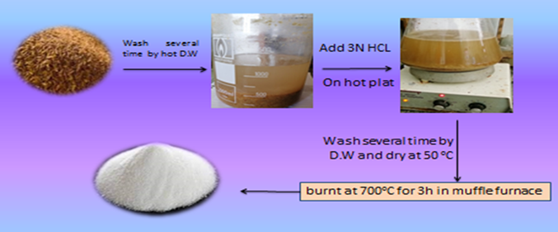

Fig. S1 Schematic preparation nanosilica from rice husk ash.

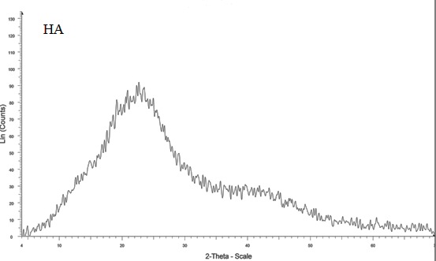

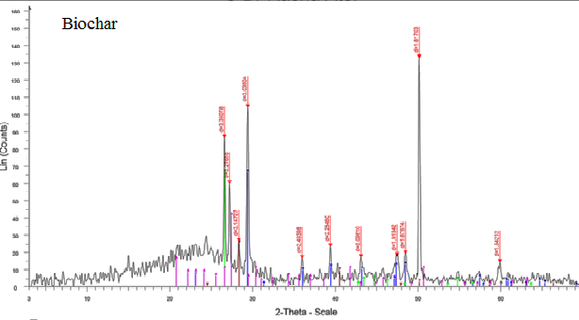

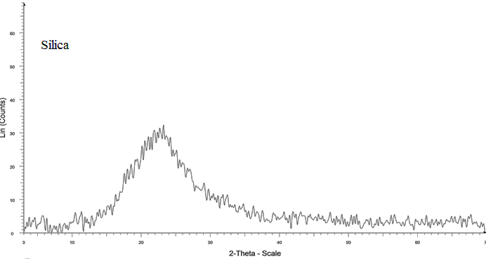

Fig. S2 XRD of humic acid, biochar and silica.

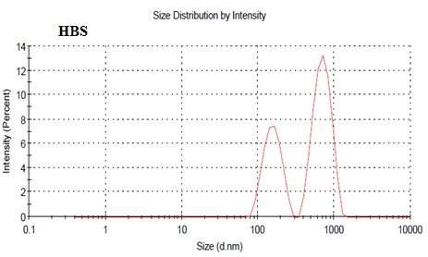

Fig. S3 Size distribution of HBS.

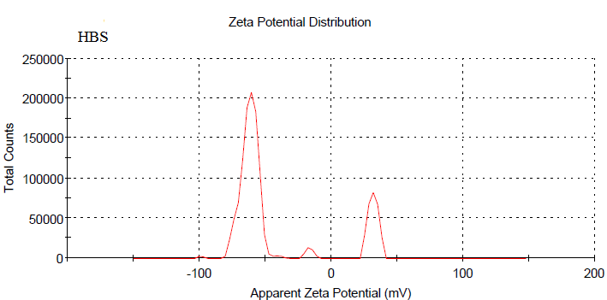

Fig.S4 Zeta potential distribution of HBS.



Fig. S5 Zero point charge of HBS.

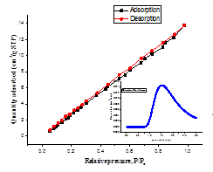

Fig. S6 N2 adsorption–desorption isotherms and corresponding pore size distribution curves (inset) of prepared composites nanoparticles.

|  |  |
| --- | --- |
|  |  |
| Fig. S7Effect of dosage of adsorbent on the removal of MB (Temp.= 25oC, time= 120 min., pH= 7, conc. of MB = 100 mg/L, sol. volume= 10 mL). | |

|  |  |
| --- | --- |
|  |  |
| Fig. S8. pH effect on MB adsorption. (Co= 100 mg/L, time= 120 min., T=25OC, adsorbent dose= 50 mg, sol. volume= 10 mL). | |

|  |  |
| --- | --- |
|  |  |
| Fig. S9.Effect of time of adsorbent on the removal of MB. (Temp.= 25oC, dose= 50 mg, pH= 7, conc. of MB = 100 mg/L, sol. volume= 10 mL). | |

|  |  |
| --- | --- |
|  |  |
| Fig. S10. Effect of MB conc. on adsorption capacity. (Temp.= 25oC, time=120 min., pH= 7, adsorbent dose= 50 mg, sol. volume=10 mL). | |

|  |  |
| --- | --- |
|  |  |
| Fig. S11 Effect of temperature on MB adsorption. (Co= 100 mg/L, time= 120 min., adsorbent dose= 50 mg, sol. volume= 10 mL). | |

  

Fig. S12 Adsorption isotherms of MB on HBS using: a) Langmiur model b) Freundlich model c) Temkin model. (Temp.= 25oC, time=120 min., pH= 7, adsorbent dose= 50 mg, sol. volume=10 mL).



Fig. S13A graph of lnKd vs. 1/T for MB adsorption on HBS.



Fig. S14 Pesudo frist order and pesudo second order of MB adsorbed on HBS.



Fig. S15. Percentage of MB (pH =7) removal by the regenerated adsorbent compared with a fresh one at (Temp.= 25oC, adsorbent dose= 50 mg, sol. volume= 10 mL, contact time= 120 min).

Table S1 Main FTIR spectra bands of HBS.

|  |  |
| --- | --- |
| **Peaks (cm-1)** | **Assignment** |
| **3416** | Frequency of H-bonding of O-H, N–H Stretching (trace). |
| **2925** | Aliphatic C-H stretching. |
| **1637-1618** | Olefinic and aromatic C=C, C=O stretching of COOH, ketones (trace), quinone and amide. |
| **1509** | Amide and/or aromatic C=C. |
| **1459** | Aliphatic C–H. |
| **1422** | COO- symmetric stretching, N–H deformation, OH-phenolic and C=N stretching. |
| **1384** | OH deformation and C=O stretching of phenolic OH, C–H deformation of CH2 and CH3 groups, COO- anti-symmetric stretching. |
| **1100** | Terminal group of the silanol group (Si–OH). |
| **802** | Aromatic ethers, possibly polysaccharides and Si-O of silicates. |
| **488** | Si-O-Si |

Table S2 Composites properties (BET surface area, total pore volume, average pore diameter and BJH cumulative adsorption surface area.

|  |  |
| --- | --- |
| Composite properties | HBS |
| BET surface area ( m2/g) | 41.68 |
| Total pore volume (cc/g) | 0.07 |
| Average pore diameter (nm) | 3.27 |
| BJH cumulative adsorption surface area (m2/g) | 34.65 |

Table S3 Effect of adsorbent dose on the removal of MB dye. (Temp.= 25oC, time=120 min., pH= 7, conc. of MB = 100 mg/L, sol. volume= 10 mL)**.**

|  |  |  |  |  |
| --- | --- | --- | --- | --- |
| Weight of adsorbent (mg) | Final conc. of MB mg/L | Removal  % | Removal  % | Adsorption capacity (mg/g) |
| 30 | 3.38 | 96.62 | 96.62 | 32.21 |
| 50 | 1.35 | 98.65 | 98.65 | 19.73 |
| 100 | 0.73 | 99.27 | 99.27 | 9.93 |
| 200 | 0.07 | 99.93 | 99.93 | 5.00 |
| 300 | 0.05 | 99.95 | 99.95 | 3.33 |

Table S4 Effect of MB dye conc. on adsorption capacity. (Temp. = 25oC, time= 120 min., pH= 7, adsorbent dose= 50 mg, sol. volume= 10 mL.

|  |  |  |  |  |
| --- | --- | --- | --- | --- |
| Initial conc. (mg/L) | Final conc.  (mg/L) | Removal  % | Kd X103 | Adsorption capacity (mg/g) |
| 75 | 2.44 | 96.75 | 5.95 | 14.51 |
| 100 | 9.05 | 90.95 | 2.01 | 18.19 |
| 125 | 15.81 | 87.35 | 1.38 | 21.84 |
| 150 | 21.87 | 85.42 | 1.17 | 25.63 |
| 200 | 23.9 | 88.05 | 1.47 | 35.22 |

Table S5 pH effect on MB dye adsorption. (Co= 100 mg/L, time= 120 min., T=25OC, adsorbent dose= 50 mg, sol. volume= 10 mL).

|  |  |  |  |  |
| --- | --- | --- | --- | --- |
| pH | Final conc.  (mg/L) | Removal  % | Kd X103 | Adsorption capacity (mg/g) |
| 3 | 20.6 | 79.4 | 0.77 | 15.88 |
| 4 | 7.5 | 92.5 | 2.47 | 18.5 |
| 5 | 6.6 | 93.4 | 2.83 | 18.68 |
| 6 | 3.5 | 96.5 | 5.51 | 19.30 |
| 7 | 1.14 | 98.86 | 17.34 | 19.77 |
| 8 | 2.3 | 97.7 | 8.50 | 19.54 |
| 9 | 1.8 | 98.2 | 10.91 | 19.64 |

Table S6 Effect of contact time on adsorption of MB (Temp.= 25oC, pH= 7, conc. of MB = 100 mg/L, sol. volume= 10 mL, adsorbent dose= 50 mg)**.**

|  |  |  |  |  |
| --- | --- | --- | --- | --- |
| Time  (min) | Final conc.  mg/L | Removal % | Kd X103 | Adsorption capacity (mg/g) |
| 5 | 19.67 | 80.33 | 0.82 | 16.07 |
| 10 | 16.84 | 83.16 | 0.99 | 16.63 |
| 30 | 12.498 | 87.50 | 1.40 | 17.50 |
| 60 | 2.7 | 97.3 | 7.21 | 19.46 |
| 120 | 1.156 | 98.84 | 17.1 | 19.77 |

Table S7 Effect of temperature on MB dye adsorption. (Co= 100 mg/L, time= 120 min., adsorbent dose= 50 mg, sol. volume= 10 mL).

|  |  |  |  |  |
| --- | --- | --- | --- | --- |
| Temperature  Co | Conc. In filtrate  (mg/L) | Removal  % | Removal  % | Adsorption capacity (mg/g) |
| 25 | 1.16 | 98.84 | 98.84 | 19.77 |
| 35 | 0.73 | 99.27 | 99.27 | 19.85 |
| 40 | 0.21 | 99.79 | 99.79 | 19.96 |
| 45 | 0.3 | 99.70 | 99.70 | 19.94 |
| 50 | 1.74 | 98.26 | 98.26 | 19.65 |