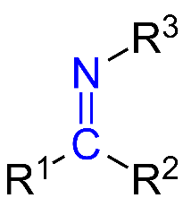

S1: The general formula of Schiff base



S2: synthesis of Schiff Base

S3: The calculated and found 1HNMR for HEA ligand

| **Comp.** | **δ (ppm)** | |
| --- | --- | --- |
| **HEA** | 5.23(1H, m, OH), 4.52(2H, m, CH2), 3.41(2H, br, CH2), 5.58(1H, br, OH), 4.27(1H, s, OH), 1.91(2H, s, ArH), 1.84(2H, m, ArH), 4.54(1H, w, OH), 1.42(3H, sh, CH3), 0.77(3H, s, CH3) | |
| **δ (ppm) map (found)** | **δ (ppm) map (calculated)** |
|  |  |

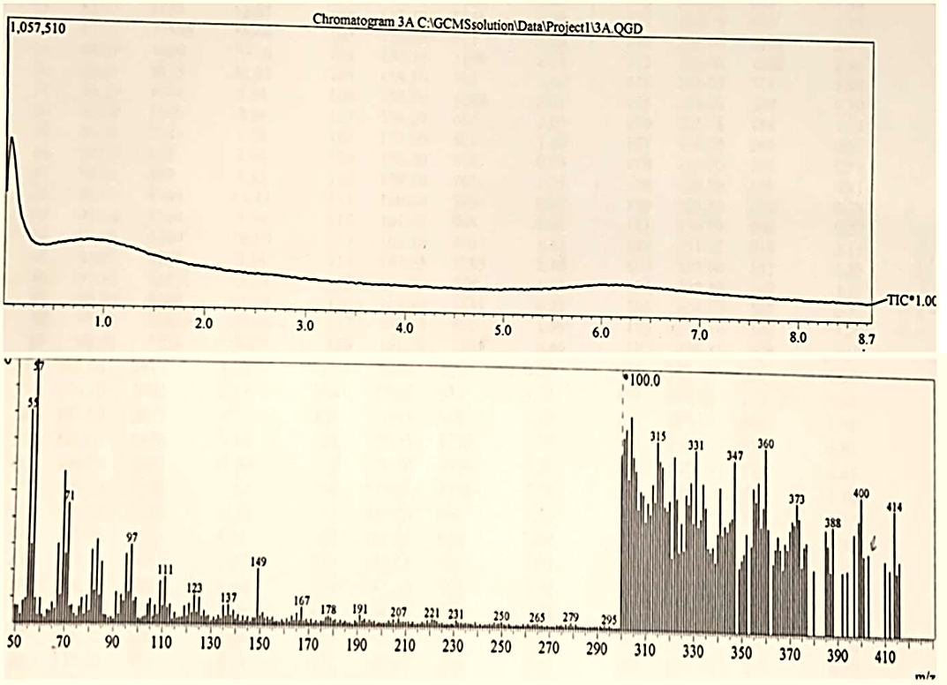

S4: Chromatogram and mass spectrum of the ligand HEA.



**S5**: FTIR spectrum of the parent drug (**Hydrocortisone**)



S6: UV-vis spectrum of the free ligand HEA



S7: FTIR spectrum of the Cu-HEA complex

 

S8: FTIR spectrum of the Ni-HEA complex S9: FTIR spectrum of the Mg-HEA complex



S10: FTIR spectrum of the VO-HEA complex



S11: TGA and DTA curves of [Cu(HEA)2Cl2]3H2O complex.



S12: TGA and DTA curves of [Ni(HEA)2Cl2] 3.5H2O complex.



S13: TGA and DTA curves of [Mg(HEA)2(H2O)(SO4)]7H2O complex.



S14: TGA and DTA curves of [VO(HEA)2(SO4)]4H2O complex.

S15 TGA and DTG of complexes derived from HEA Schiff base.

|  |  |  |  |  |  |  |  |
| --- | --- | --- | --- | --- | --- | --- | --- |
| **Compound** | **Temp. range °C** | **DTG temp.**  **°C** | **Mass loss %** | | **Process** | **Expected product** | **Residue**  **Found**  **Calc.** |
| **Found** | **Calculated** |
| **[Cu(HEA)2Cl2]3H2O** | **13-109** | **56** | **5.77** | **5.41** | **Dehydration** | **3H2O** | **No residue** |
| **109-218** | **164** | **8.89** | **8.93** | **Ligand decomposition** | **0.08L** |
| **218-600** | **460** | **85.11** | **85.61** | **Final decomposition** | **2HCL+0.91L** |
| **[Ni(HEA)2Cl2] 3.5H2O** | **29-129** | **66** | **6.03** | **6.28** | **Dehydration** | **3.5H2O** | **NiO + C**  **8.17**  **8.58** |
| **129-600** | **424** | **85.85** | **84.86** | **Final decomposition** | **2HCL+0.87L** |
| **[Mg(HEA)2(H2O)(SO4)]7H2O** | **15-120** | **68** | **12.64** | **11.72** | **Dehydration** | **7H2O** | **MgO + 5C**  **9.79**  **9.29** |
| **120-600** | **462** | **77.41** | **78.95** | **Final decomposition** | **H2O+SO2+0.8L** |
| **[VO(HEA)2(SO4)]4H2O** | **15-153** | **52** | **6.9** | **6.9** | **Dehydration** | **4H2O** | **7C + VO**  **15.2**  **14.36** |
| **153-535** | **422** | **77.86** | **78.48** | **Final decomposition** | **SO2+ 0.79L** |

S16: DTA of complexes derived from HEA Schiff base.

|  |  |  |  |  |  |
| --- | --- | --- | --- | --- | --- |
| **Compound** | **Temp. range °C** | **DTA peak temp. °C** | **Peak type** | **ΔH (J/g)** | **Process** |
| **[Cu(HEA)2Cl2]3H2O** | 29-105 | 58 | Endo | 68 | Dehydration |
| 262-448 | 387 | Exo | -2580 | Ligand decomposition |
| 581-601 | 574 | Endo | 12 | Final decomposition |
| **[Ni(HEA)2Cl2] 3.5H2O** | 36-112 | 69 | Endo | 122 | Dehydration |
| 416-448 | 427 | Exo | -232 | Ligand decomposition |
| 495-598 | 533 | Endo | 1950 | Ligand decomposition |
| 580-675 | 624 | Exo | -1410 | Ligand decomposition |
| 677-692 | 687 | Endo | 283 | Final decomposition |
| **[Mg(HEA)2(H2O)(SO4)]7H2O** | 69-103 | 85 | Endo | 58 | Dehydration |
| 200-343 | 284 | Endo | 338 | Ligand decomposition |
| 388-439 | 417 | Endo | 79 | Ligand decomposition |
| 4448-506 | 480 | Endo | 54 | Ligand decomposition |
| 524-551 | 539 | Endo | 119 | Final decomposition |
| **[VO(HEA)2(SO4)]4H2O** | 27-116 | 48 | Endo | 140 | Dehydration |
| 43-372 | 276 | Exo | -193 | Ligand decomposition |
| 445-503 | 498 | Exo | -6570 | Final decomposition |

S17: The kinetic parameters for the selected decomposition steps of the complexes of the HEA ligand.

|  |  |  |  |  |  |  |  |  |  |
| --- | --- | --- | --- | --- | --- | --- | --- | --- | --- |
| **Compounds** | **Step** | **R2** | **Order**  **(n)** | **Ts**  **(K)** | **ΔEa**  **(J/mol)** | **Z**  **(S-1)** | **ΔS\***  **(J/K.mol)** | **ΔH\***  **(kJ/mol)** | **ΔG\***  **(kJ/mol)** |
| **[Cu(HEA)2Cl2]3H2O** | Dehydration | 0.96 | 2 | 329.12 | 31.16 | 1.87*104 | -125.67 | -2.71 | 38.66 |
| Ligand decomposition | 0.97 | 2 | 702.89 | 123.69 | 6.78*108 | -44.70 | -5.72 | 25.69 |
| Final decomposition | 0.95 | 0 | 814.53 | 79.0 | 2.34*104 | -131.37 | -6.69 | 100.31 |
| **[Ni(HEA)2Cl2] 3.5H2O** | Dehydration | 0.96 | 2 | 337.02 | 20.16 | 1.69*102 | -165.04 | -2.78 | 52.84 |
| Final decomposition | 0.97 | 2 | 766.4 | 162.14 | 8.19*1010 | -5.55 | -6.21 | -1.96 |
| **[Mg(HEA)2(H2O)(SO4)]7H2O** | Dehydration | 0.97 | 2 | 309.86 | 54.20 | 4.67*108 | -40.99 | -2.52 | 10.18 |
| Final decomposition | 0.95 | 2 | 785.52 | 196.35 | 1.45*1013 | 37.26 | -6.33 | -35.61 |
| **[VO(HEA)2(SO4)]4H2O** | Final decomposition | 0.98 | 0 | 769.15 | 135.73 | 7.09*108 | -45.08 | -6.26 | 28.41 |



**B**

**A**



**D**

**C**

**S18: The fit-linear curve of the selected decomposition step for:** **Cu-HEA (A), Ni-HEA (B), Mg-HEA (C), and VO-HEA (D).**



S19: UV-Vis. Spectrum of [Ni(HEA)2Cl2] 4H2O complex.



S20: UV-Vis. Spectrum of [Mg(HEA)2(H2O)(SO4)]7H2O complex. S21: UV-Vis. Spectrum of [VO(HEA)2(SO4)]4H2O complex.



**(A)**



**(B) (C)**

S22: The postulated structures of complexes derived from HEA ligand (A) Ni-HEA, (B) Mg-HEA and (C) VO-HEA

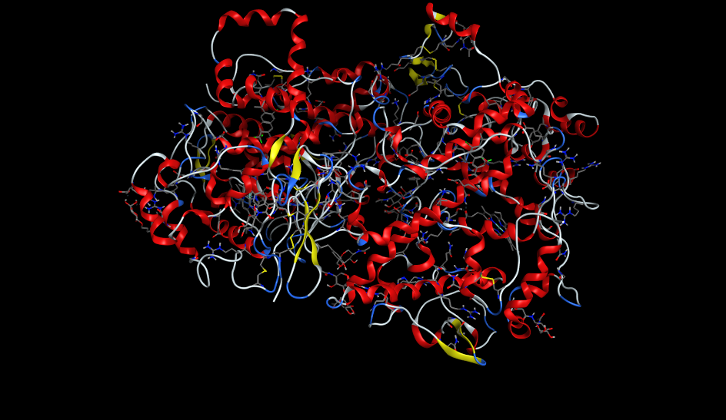

S23: 3D model of the 5IKT (Homo sapiens) receptor





**(A)**

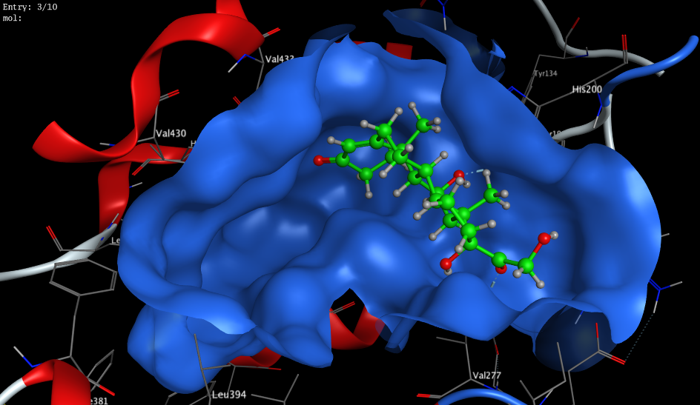

**(B)**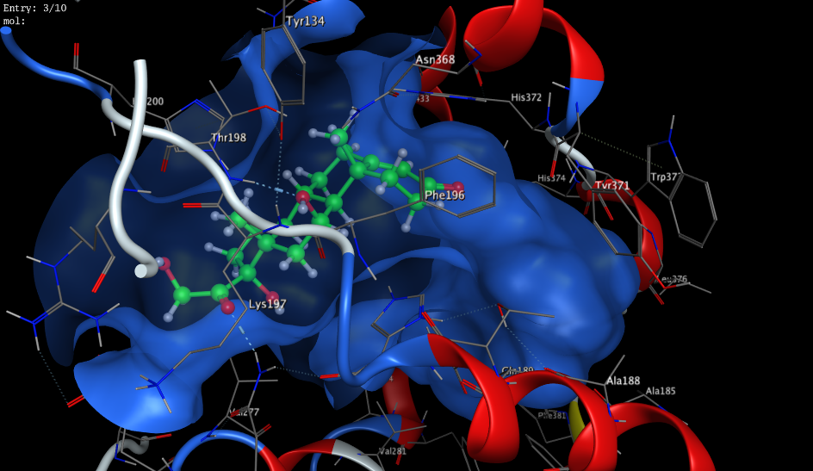

**(C)**

S24: Docking model of the interaction of Hydrocortisone with COX2[PDB 5IKT (*Homo sapiens*)] bonding sites.

(A) 2D interaction diagram (B) 3D cavity interaction diagram (C) 3D overall interaction diagram.



S25: Docking model of the interaction of HEA with COX2[PDB 5IKT (*Homo sapiens*)] bonding sites. 2D interaction diagra