S1 Average Crystal size (nm) of adsorbents before and after (Fe²⁺) ion removal.
Character | Average crystal size (nm) before removal (Fe²⁺) ions | Average crystal size (nm) after removal (Fe²⁺) ions
DCP | 47 | 48
(DCP – CS1) | 41 | 42
(DCP – CS2) | 32 | 44

S2 IR spectra λ (cm⁻¹) and assignments for adsorbents after removal (Fe²⁺) ions.
(DCP)  + Fe²⁺ | (DCP-CS1) + Fe²⁺ | (DCP-CS2) + Fe²⁺ | Assignments
3447.46 | 3443.07 | 3443.50 | O–H stretching of residual free water
2925.37  2857.41 | 2956.93  2924.02  2853.80 | 2960.66  2924.67  2854.29 | (P) O–H stretching
1639.05 | 1630 | 1630 | H –O–H bending and rotation of residual free water
- | 1638.04 | 1645.02 | C= O stretching of amide I
- | 1451.51 | 1373 | Amino II (-NH₂)
1132.08  1072.30  1001.27 | 1131.04  1070.40  1000.16 | 1126.99  1069.85  1001.83 | P–O stretching
897.48 | 894.49 | 896.14 | P–O(H) stretching
575.09 | 565.54 | 563.59 | O–P–O(H) bending mode

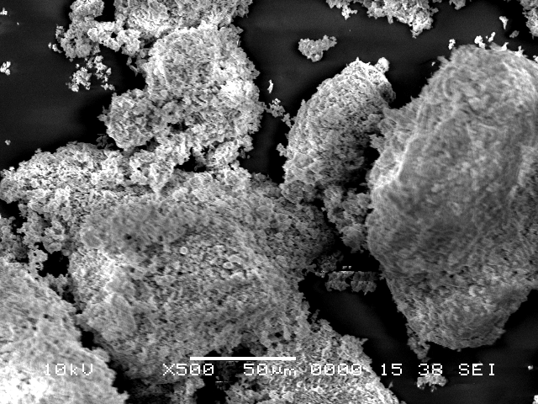 | 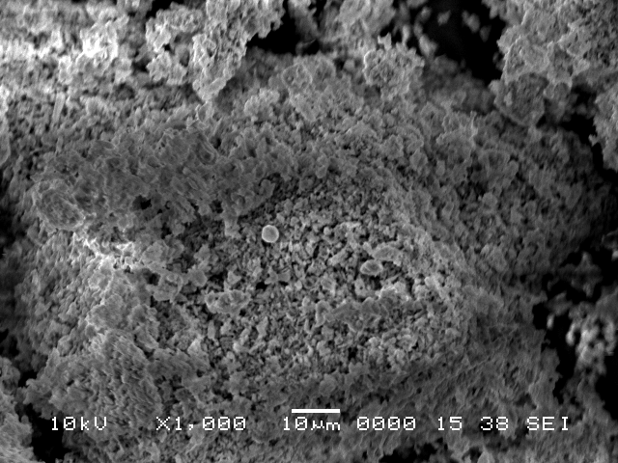
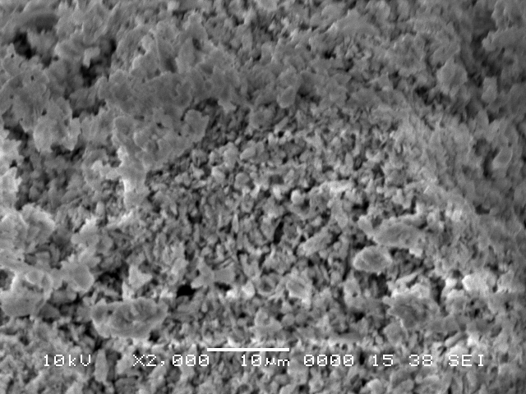 | Element Wt % At %  C K 4.68 9.63  O K 29.75 46.02  Na K 0.17 0.18  P K 21.23 16.94  Ca K 44.17 27.23  Total 100 100

S3 SEM images and EDX analysis of (DCP)

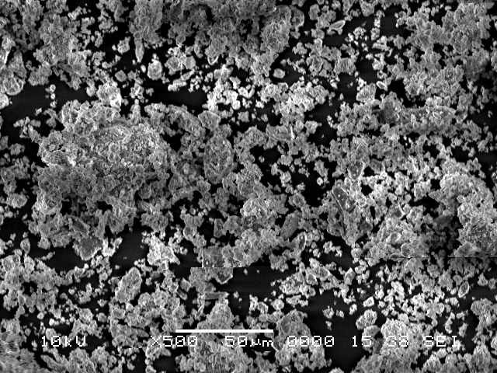 | 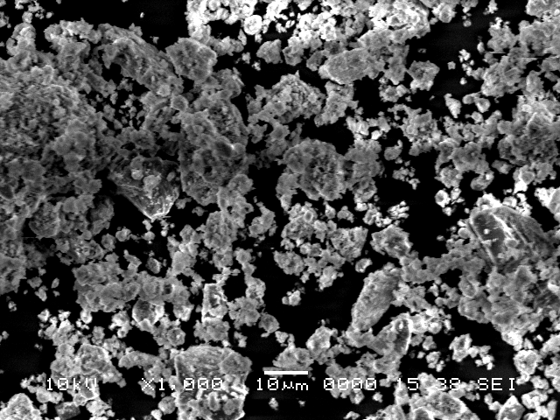
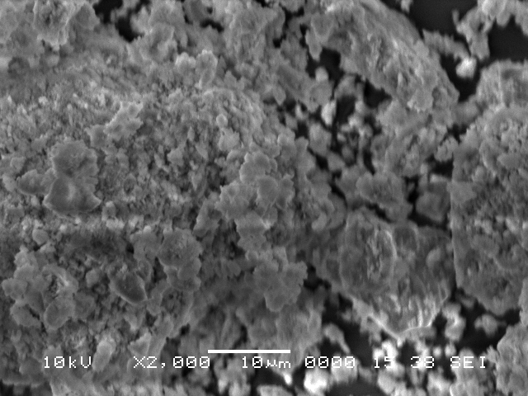 | Element Wt % At %  C K 8.04 14.73  N K 3.23 3.13  O K 30.21 45.02  Na K 0.31 0.32  P K 17.04 13.22  Ca K 41.17 23.58  Total 100 100

S4 SEM images and EDX analysis of (DCP-CS2)

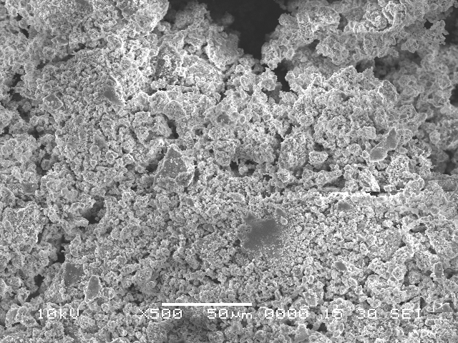 | 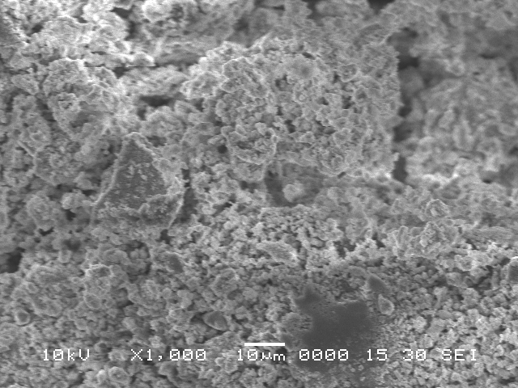
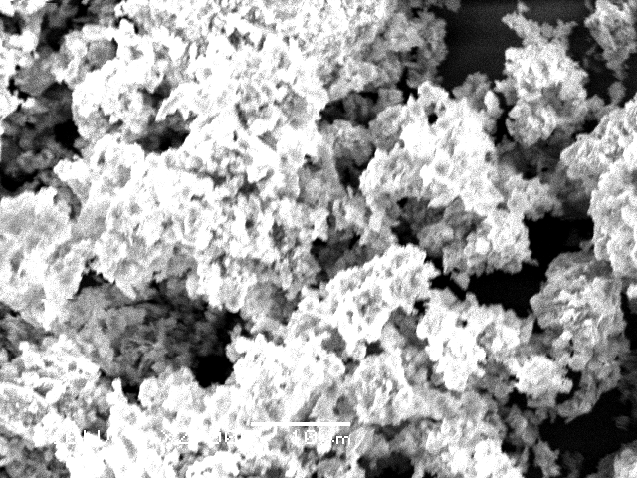 | Element Wt % At %  C K 5.53 11.55  O K 27.97 43.84  Na K 0.10 0.11  P K 20.17 16.33  Ca K 41.92 26.23  Fe K 4.31 1.93  Total 100 100
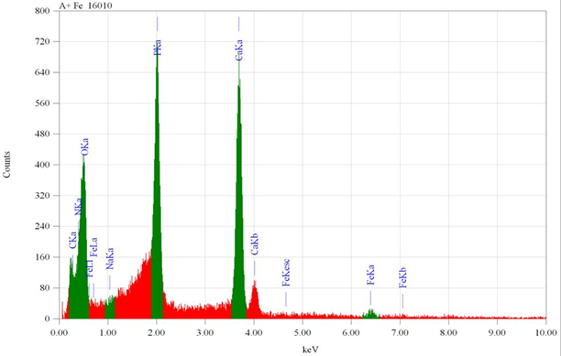

S5 SEM images and EDX analysis of (DCP) after (Fe²⁺) ions uptake

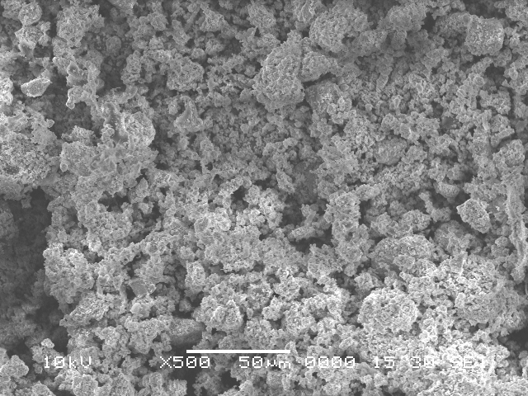 | 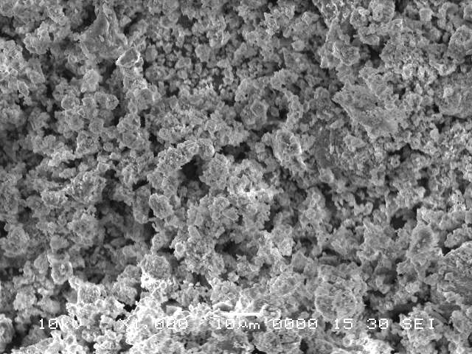
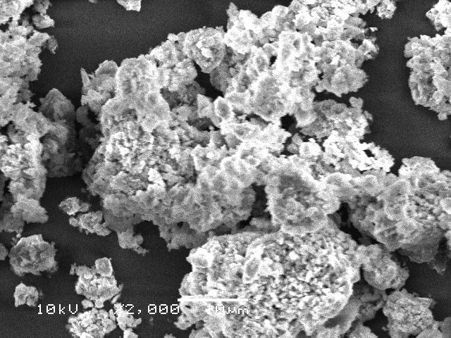 | Element Wt % At %  C K 9.59 19.63  N K 3.11 3.10  O K 23.16 36.06  Na K 0.31 0.33  P K 17.34 13.56  Ca K 41.33 25.05  Fe K 5.16 2.27  Total 100 100
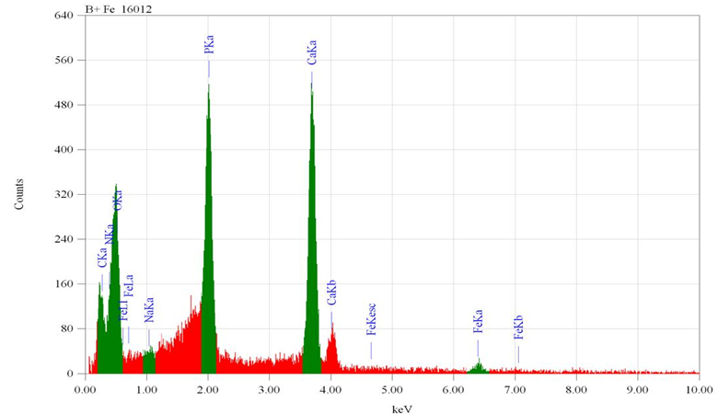

S6 SEM images and EDX analysis of (DCP-CS1) after (Fe²⁺) ions uptake
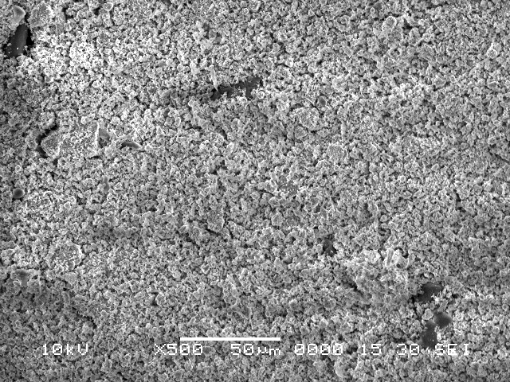 | 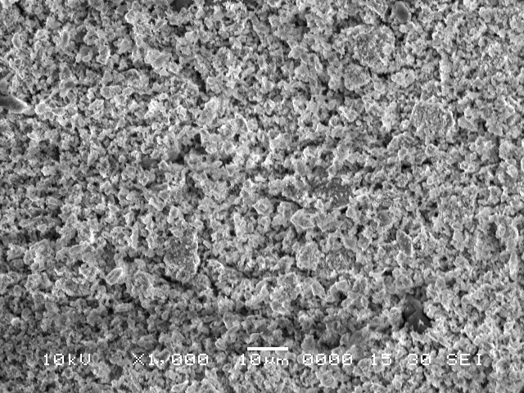
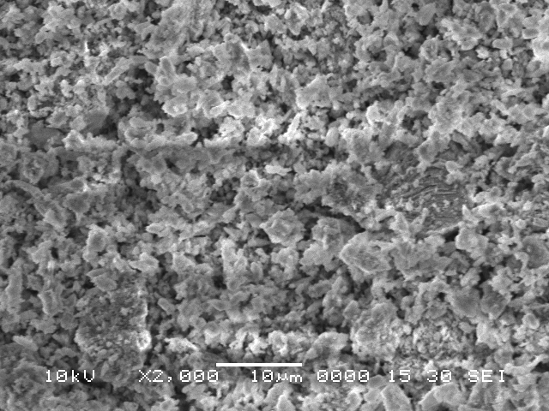 | Element Wt % At %  C K 9.82 20.28  N K 3.24 3.21  O K 27.14 40.47  Na K 0.37 0.38  P K 16.79 12.31  Ca K 38.62 21.65  Fe K 4.02 1.70  Total 100 100
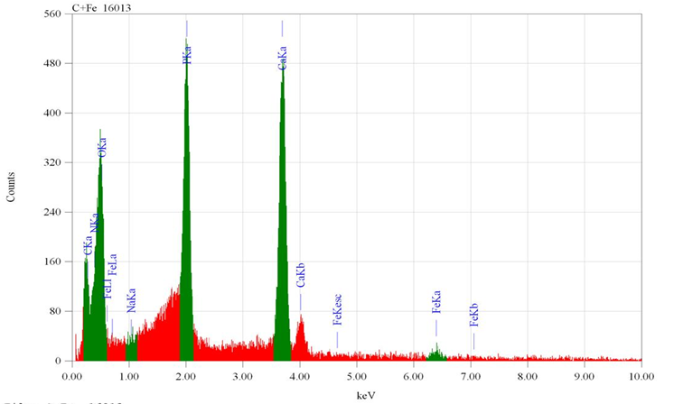

S7 SEM images and EDX analysis of (DCP-CS2) after (Fe²⁺) ions uptake

S8 Effect the dose of (DCP) and (DCP-CS1) at 120 min., (DCP-CS2) at 60 min. on (Fe²⁺) ions , initial concentration of 100 mgL⁻¹, natural pH of 4.9 at temperature 25±1ºC

S9 Effect the dose of (DCP) on the (Fe²⁺) ions Adsorption

S.NO. | Adsorbent dose (mg) | C _{e} (mg/L) | Amount adsorbed, q (mg/g) | Removal % of (Fe²⁺) ions
1 | 20 | 60 | 20 | 40
2 | 40 | 38 | 15.5 | 62
3 | 60 | 25 | 12.5 | 75
4 | 80 | 21.33 | 9.83 | 78.67
5 | 100 | 12.5 | 8.75 | 87.5

S10 Effect the dose of (DCP – CS1) on the (Fe²⁺) ions Adsorption

S.NO. | Adsorbent dose (mg) | C _{e} (mg/L) | Amount adsorbed, q (mg/g) | Removal % of (Fe²⁺) ions
1 | 20 | 58 | 21 | 42
2 | 40 | 40 | 15 | 60
3 | 60 | 24 | 12.6 | 76
4 | 80 | 20 | 10 | 80
5 | 100 | 12 | 8.8 | 88

S11 Effect the dose of (DCP – CS2) on the (Fe²⁺) ions Adsorption

S.NO. | Adsorbent dose (mg) | C _{e} (mg/L) | Amount adsorbed, q (mg/g) | Removal % of (Fe²⁺) ions
1 | 20 | 36 | 32 | 64
2 | 40 | 15.33 | 21.16 | 84.67
3 | 60 | 12.66 | 14.55 | 87.34
4 | 80 | 12.66 | 10.91 | 87.34
5 | 100 | 8 | 9.2 | 92

S12 Effect of contact time on (Fe²⁺) ions adsorption (pH=4.9) from solutions under conditions of (DCP), (DCP-CS1) and (DCP-CS2) mass 100 mg/10 mL, 50 mg/L (Fe²⁺) ions concentration at temperature 25±1ºC

S13 Equilibrium Data for (Fe²⁺) ions removal by (DCP) at Different Times

S.NO. | Contact Time / minutes | C _{e} (mg/L) | Amount adsorbed, q (mg/g) | Removal % of (Fe²⁺) ions
1 | 1 | 41.25 | 0.875 | 17.5
2 | 2 | 37.6 | 1.240 | 24.8
3 | 5 | 27.25 | 2.275 | 45.5
4 | 10 | 23 | 2.70 | 54
5 | 15 | 19.25 | 3.075 | 61.5
6 | 20 | 12 | 3.80 | 76
7 | 25 | 10 | 4 | 80
8 | 30 | 7 | 4.30 | 86
9 | 40 | 4.50 | 4.55 | 91
10 | 50 | 3.75 | 4.625 | 92.5
11 | 60 | 2.80 | 4.720 | 94.4
12 | 70 | 2.33 | 4.767 | 95.34
13 | 80 | 2.33 | 4.767 | 95.34
14 | 100 | 2.33 | 4.767 | 95.34

S14 Equilibrium Data for (Fe²⁺) ions removal by (DCP – CS1) at Different Times

S.NO. | Contact Time / minutes | C _{e} (mg/L) | Amount adsorbed, q (mg/g) | Removal % of (Fe²⁺) ions
1 | 1 | 40 | 1 | 20
2 | 2 | 34.75 | 1.525 | 30.5
3 | 5 | 22 | 2.8 | 56
4 | 10 | 18.5 | 3.15 | 63
5 | 15 | 14.1 | 3.59 | 71.8
6 | 20 | 10 | 4 | 80
7 | 25 | 7.75 | 4.22 | 84.5
8 | 30 | 6 | 4.40 | 88
9 | 40 | 4 | 4.60 | 92
10 | 50 | 3.25 | 4.675 | 93
11 | 60 | 2.55 | 4.745 | 94.9
12 | 70 | 2 | 4.8 | 96
13 | 80 | 2 | 4.8 | 96
14 | 100 | 2 | 4.8 | 96

S15 Equilibrium Data for (Fe²⁺) ions adsorption by (DCP – CS2) at Different Times

S.NO. | Contact Time / minutes | C _{e} (mg/L) | Amount adsorbed, q (mg/g) | Removal % of (Fe²⁺) ions
1 | 1 | 35.5 | 1.45 | 29
2 | 2 | 29 | 2.1 | 42
3 | 5 | 19.5 | 3.05 | 61
4 | 8 | 13 | 3.70 | 74
5 | 10 | 10.5 | 3.95 | 79
6 | 12 | 9 | 4.1 | 82
7 | 15 | 7 | 4.3 | 86
8 | 20 | 5.5 | 4.45 | 89
9 | 25 | 4.75 | 4.525 | 90.5
10 | 30 | 3.75 | 4.625 | 92.5
11 | 40 | 3 | 4.7 | 94
12 | 50 | 2.25 | 4.775 | 95.5
13 | 60 | 1.33 | 4.867 | 97.34
14 | 70 | 1 | 4.9 | 98
15 | 80 | 1 | 4.9 | 98

S16: Effect of intial concentration on the adsorption of (Fe²⁺) ions at pH= 4.9, from solution by (DCP), (DCP-CS1) and (DCP-CS2) under conditions of mass 100 mg/10 mL at 120 min. and temperature of 25±1ºC

S17 Initial (Fe²⁺) ions metal concentration effect on (DCP) adsorption Mechanism

S.NO. | C ₀ (mg/L) | C _{e} (mg/L) | Amount adsorbed, q (mg/g) | Removal % of (Fe²⁺) ions
1 | 25 | 1.13 | 2.38 | 95.48
2 | 50 | 2.33 | 4.76 | 95.34
3 | 100 | 12.5 | 8.75 | 87.5
4 | 150 | 39 | 11.1 | 74
5 | 200 | 88 | 11.2 | 56
6 | 250 | 113.33 | 13.66 | 54.66

S18 Initial (Fe²⁺) ions metal concentration effect on (DCP – CS1) adsorption Mechanism

S.NO. | C ₀ (mg/L) | C _{e} (mg/L) | Amount adsorbed, q (mg/g) | Removal % of (Fe²⁺) ions
1 | 25 | 0.73 | 2.43 | 97.08
2 | 50 | 2 | 4.8 | 96
3 | 100 | 12 | 8.8 | 88
4 | 150 | 33.99 | 11.60 | 77.34
5 | 200 | 73.33 | 12.67 | 63.34
6 | 250 | 101.66 | 14.83 | 59.34

S19 Initial (Fe²⁺) ions metal concentration effect on (DCP – CS2) adsorption Mechanism

S.NO. | C ₀ (mg/L) | C _{e} (mg/L) | Amount adsorbed, q (mg/g) | Removal % of (Fe²⁺) ions
1 | 25 | 0.23 | 2.48 | 99.08
2 | 50 | 1.33 | 4.86 | 97.34
3 | 100 | 8 | 9.2 | 92
4 | 150 | 13.99 | 13.60 | 90.67
5 | 200 | 28 | 17.2 | 86
6 | 250 | 65 | 18.5 | 74

S20 Pseudo-first-order of (Fe²⁺) ions (pH=4.9), adsorbed on (DCP), (DCP – CS1) and(DCP – CS2) at conditions of 50 mg/L metal ions concentration, mass 100 mg/10 mL at 25±1ºC

S21 Experimental and calculated parameters of pseudo-first and second order kinetic of (Fe²⁺) ions (natural pH of 4.9) on (DCP), (DCP – CS1) and (DCP – CS2)
Kinetic parameters  Adsorpent | q_{e} experimental | Pseudo- first- order |  |  | Pseudo- second- order
 |  | q_{e} calculated | K₁ | R² | q_{e} calculated | K₂ | R²
DCP | 4.767 | 3.7899 | 0.07195 | 0.99177 | 5.2929 | 0.02519 | 0.99299
(DCP – CS1) | 4.8 | 3.3498 | 0.0691 | 0.99048 | 5.0836 | 24.5061 | 0.9993
(DCP – CS2) | 4.9 | 2.3097 | 0.06752 | 0.9466 | 5.0831 | 0.067421 | 0.99991

