## 2.4. Preparation of humic acid

Extraction of humic substances was run according to Sanchez – Monedero et al. [8]. A mixture of 40 g of the compost and 800 ml of 0.5N NaOH were shaken for 12 hours then centrifuged for 15 minutes at 6000 rpm then the supernatant was removed. The pH of filtrate was adjusted at 2.0 or slightly less by dropping of 2 M H2SO4. The formed precipitate of humic acid (HA) was allowed to coagulate for 24 hours at 4 oC, then separated from the soluble fulvic acid, and centrifuged for 15 minutes at 6000 rmp. The coagulated precipitate was washed twice with 0.1 M H2SO4 and then with deionized water, one part of HA was freeze-dried for storage (unpurified humic acid).

The precipitated humic acid was washed several times with cold 0.05 N HCl until the filtrate became colorless. The humic acid was redissolved in a small amount of 0.5 N NaOH solution, and then transferred to a membrane filter. It was precipitated again by acidification to pH 1.0. The humic acid was transferred to cellophane bags and dialyses against distilled water until the test for Cl- in the distilled water outside the bags was negative, then humic was air-dried #. In order to reduce the ash content of the purified humic acid and to increase its purity, the humic acids solution was treated with 0.5 % HCl-HF solution (5 ml HCI and 5 ml HF per liter) for 36 hours # at room temperature the suspension was then centrifuged for 15 minutes at 6000 rpm. The precipitate washed twice with 0.1 M HCl and one time with deionized water. The formed humic acid was washed by distilled water until became chloride free then transferred to Petri dishes and dried at room temperature as show in **Figure S1.**

## 2.5. Preparation of nanosilica

Nanosilica has been prepared from rice husk. First, rice husk washed by warm deionised water. Pure silica was extracted by refluxing the washed rice husk with 6 N HCI for 4h. The silica produced was washed several times using deionized water then it was burnt at 700oC for 3h in muffle furnace Stuart Scientific as shown in **Figure S2**.

### 3.1.1. Infrared spectroscopy

Infrared spectroscopy of humic acid, silica and prepared nanocomposite are presented in **Figure 2** and **Table (S1-S3)**.The main absorbance bands of humic acid were: a broad band at 3425-3419 cm-1 due to frequency of H-bonding of O-H, N–H Stretching, a band at 2934-2932 cm-1 due to Aliphatic C-H stretching content in humic acid, a strong band at 1648-1645 cm-1 due to Olefinic and aromatic C=C, C=O stretching of COOH, ketones (trace), quinone and amide, a shoulder at 1638-1510 due to Aromatic C=C, strong H-bond C=O conjugated ketones, a band at 1510-1506 cm-1 due to amide and/or aromatic C=C, a band at 1460-1448 cm-1 due to Aliphatic C–H, a more pronounced peak at 1422-1384 cm-1 due to COO- symmetric stretching, N–H deformation, OH-phenolic and C=N stretching, a weak band at 1384-1332 cm-1 due to OH deformation and C=O stretching of phenolic OH, C–H deformation of CH2 and CH3 groups, COO- anti-symmetric stretching, a band at 1125-1122 cm-1 due to aliphatic CH2, OH or C–O groups, a peak at 1042-11029 cm-1 due C–O stretching of carbohydrates, and finally a band at 601-589 cm-1 due to Para-di-substituted aromatic ring bend #. FTIR of silica was extract from rice husk ash, exhibits broad bands at 470 and 1100 cm-1, which are assigned to Si–O–Si and the silicate ion. The peak related to the tetrahedral silica matrix is occurred at 803 cm-1. The sharp peak at 1100 cm-1 represents the terminal group of the silanol group (Si–OH). The purified silica spectrum exhibits a sorption peak at 3419 cm-1, indicating the presence of the hydroxyl group of Si-OH #, while peaks at 1638– 1700 cm-1 are contribute ions from oxygen functional groups.

Compost

0.5N NaOH to compost for 24 hour

Filtration of (soluble HA and FA)

Acidify to pH ≤ 2

HA insoluble

Filterate FA

Wash by distilled water several times

Soluble in 0.5M KOH

Purified HA

Shake with 0.5% HF: HCl solution

Figure S1 Schematic representation for extraction and purification of humic acid from compost.

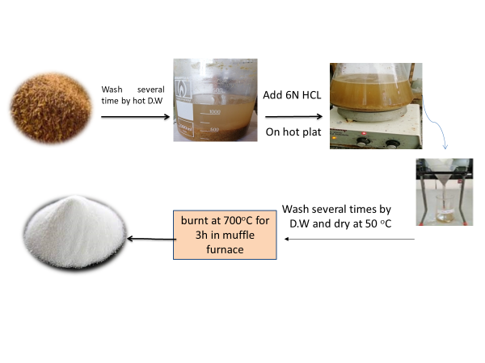

Figure S2 Schematic preparation nanosilica from rice husk ash.

Table S1 Main FTIR spectra of humic acid.

|  |  |
| --- | --- |
| Peaks (cm-1) | Assignment |
| 3419 | Frequency of H-bonding of O-H, N–H Stretching (trace). |
| 2925 | C-H stretching. |
| 1638 | Olefinic and aromatic C=C, C=O stretching of COOH, ketones (trace), quinone and amide. |
| 1510 | N-O stretching, Amide and/or aromatic C=C. |
| 1460 | Aliphatic C–H. |
| 1422 | COO- symmetric stretching, N–H deformation, OH-phenolic and C=N stretching. |
| 1384 | OH deformation and C-O stretching of phenolic OH, C–H deformation of CH2 and CH3 groups, COO- anti-symmetric stretching. |
| 1221 | C–O Stretching and OH deformation of COOH, C–O stretching of aryl ethers. |
| 1125 | Aliphatic CH2, OH or C–O groups. |
| 1031 | C–O stretching of carbohydrates. |
| 618 | Para-di-substituted aromatic ring bend |

Table S2 Main FTIR spectra bands of silica.

|  |  |
| --- | --- |
| Peaks (cm-1) | Assignment |
| 3419 | Frequency of H-bonding of O-H. |
| 1638 | the band of surface hydroxyl groups of silica and Si–O–Si band |
| 1100 | Terminal group of the silanol group (Si–OH). |
| 803-619 | The symmetric stretching vibrations of Si-O-Si correspond to the band |
| 470 | Si-O-Si |

Table S3 Main FTIR spectra bands of HS.

|  |  |
| --- | --- |
| Peaks (cm-1) | Assignment |
| 3455-3417 | Frequency of H-bonding of O-H, N–H Stretching (trace). |
| 2925 | Aliphatic C-H stretching. |
| 1638-1618 | Olefinic and aromatic C=C, C=O stretching of COOH, ketones (trace), quinone and amide. / or the band of surface hydroxyl groups of silica and Si–O–Si band |
| 1510 | Amide and/or aromatic C=C. |
| 1461 | Aliphatic C–H. |
| 1384 | OH deformation and C=O stretching of phenolic OH, C–H deformation of CH2 and CH3 groups, COO- anti-symmetric stretching. |
| 1104 | Terminal group of the silanol group (Si–OH). |
| 804 | Aromatic ethers, possibly polysaccharides and Si-O of silicates. |
| 489 | Si-O-Si |

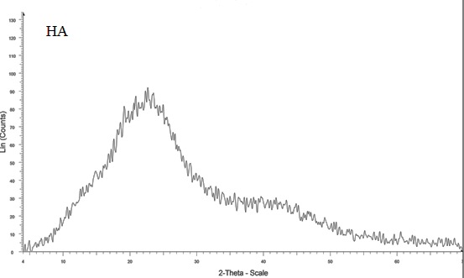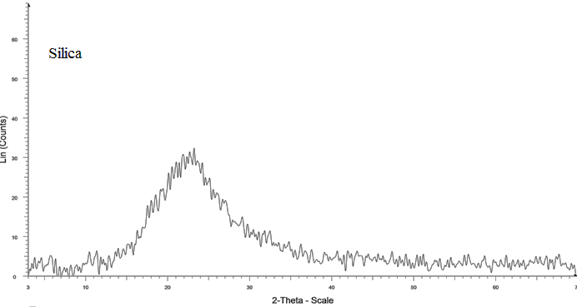

Figure S3 XRD of humic acid and silica.

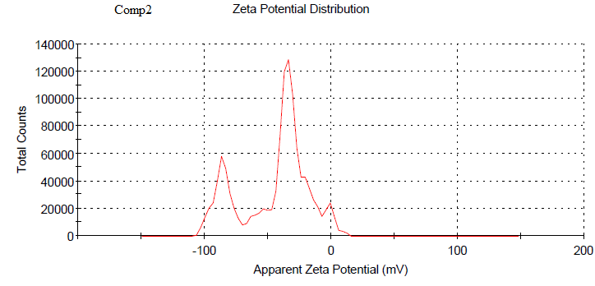

**Figure S4** Zeta potential distribution of HS.



**Figure S5** Zero point charge of HS.

**Table S4.** Nanocomposite’s properties using BET and BJH parameters.

|  |  |  |  |  |
| --- | --- | --- | --- | --- |
| BET surface area ( m2/g) | Total pore volume (cc/g( | Average pore diameter (nm) | | BJH cumulative adsorption surface area (m2/g) |
| 27.52 | 0.02 | | 1.53 | 12.38 |

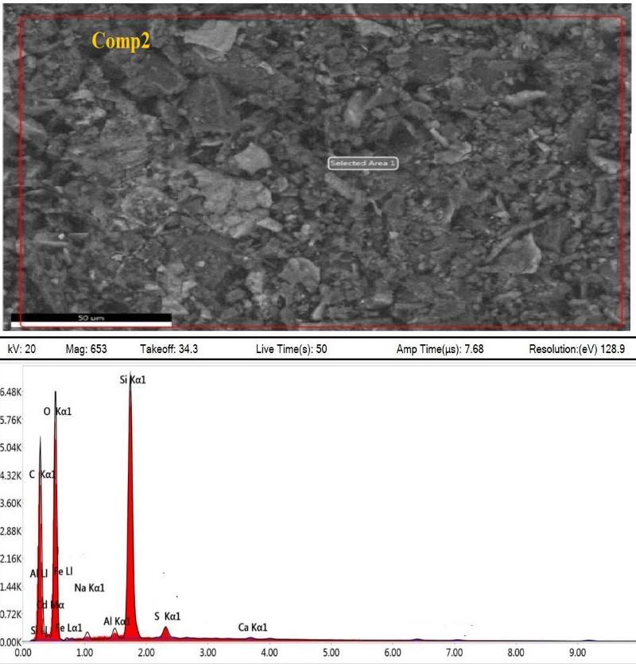

**Figure S6** EDX spectra of HS nanocomposite.

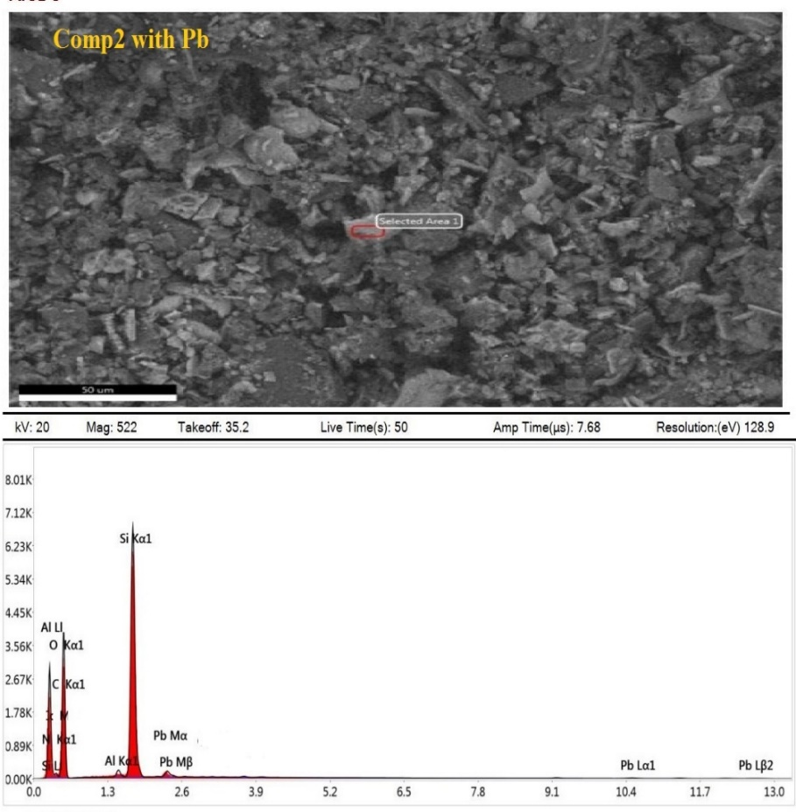

**Figure S7** EDX spectra of HS nanocomposite with Pb2+.

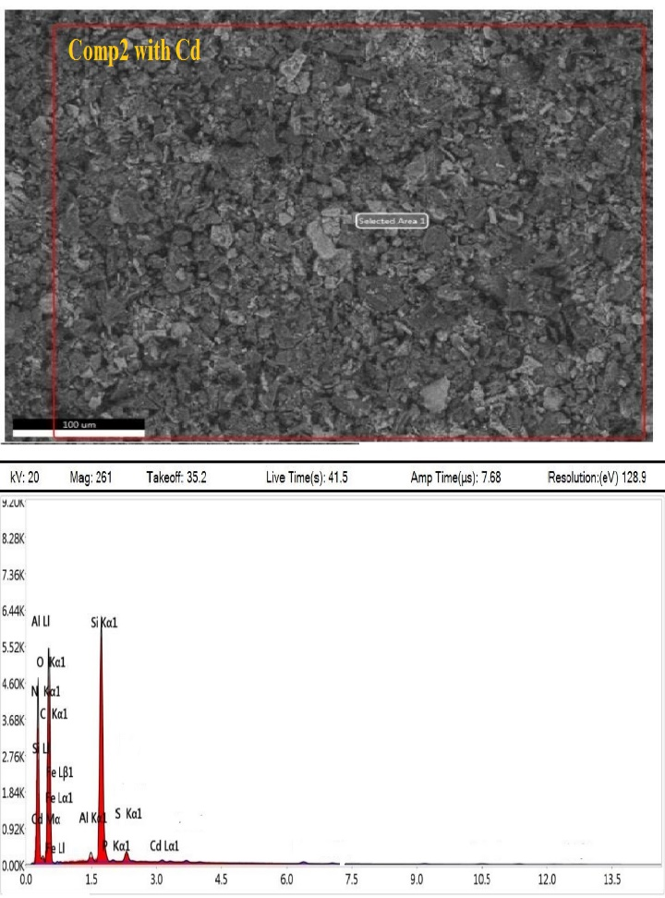

**Figure S8** EDX spectra of HS nanocomposite with Cd2+.

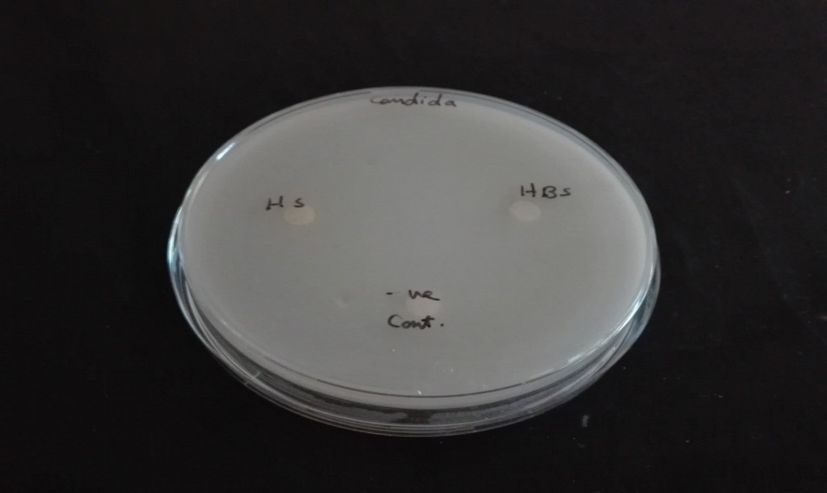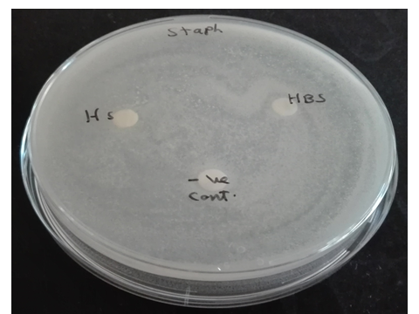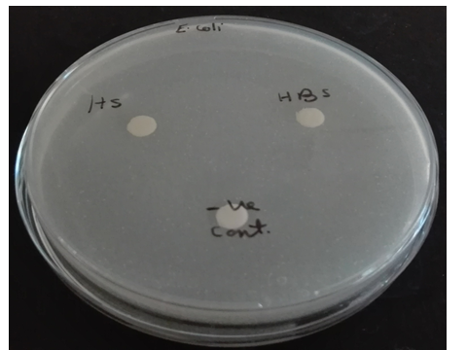

**Figure S9** Antimicrobial Activity of nanocomposite with Staphylococcus aureus, Escherichia coli and Candida albicans, all plates were showed negative results.

**Table S5** Effect of adsorbent dose on the removal of Pb2+ and Cd2+. (Temp. = 25oC, time=120 min., pH= 6, conc. 100 mg/L, sol. volume= 10 mL).

|  |  |  |  |  |  |  |  |  |
| --- | --- | --- | --- | --- | --- | --- | --- | --- |
| Weight of adsorbent (mg) | HS and Pb2+ | | | | HS and Cd2+ | | | |
| Final conc. of Pb2+  mg/L | Removal % | Kd X103 | qe | Final conc. of Cd2+  mg/L | Removal % | Kd X103 | qe |
| 30 | 24.07 | 75.93 | 1.05 | 25.31 | 84.43 | 15.57 | 0.06 | 5.19 |
| 50 | 10.19 | 89.81 | 1.76 | 17.96 | 79.31 | 20.69 | 0.05 | 4.14 |
| 100 | 3.21 | 96.79 | 3.02 | 9.68 | 32.15 | 67.85 | 0.21 | 6.79 |
| 200 | 2.01 | 97.99 | 2.44 | 4.90 | 11.28 | 88.72 | 0.39 | 4.41 |
| 300 | 0.35 | 99.65 | 9.39 | 3.32 | 6.86 | 93.14 | 0.45 | 3.11 |

**Table S6** pH effect on Pb2+ and Cd2+ adsorption. (Co= 100 mg/L, time= 120 min., T=25OC, adsorbent dose= 300 mg, sol. volume= 10 mL).

|  |  |  |  |  |  |  |  |  |  |
| --- | --- | --- | --- | --- | --- | --- | --- | --- | --- |
| pH | HS and Pb2+ | | | | pH | HS and Cd2+ | | | |
| Final Conc. of Pb2+  mg/L | Removal % | Kd | qe | Final conc. of Cd2+ mg/L | Removal % | Kd X 103 | qe |
| 4 | 0.74 | 99.26 | 33.09 | 3.31 | 4 | 53.54 | 46.46 | 0.29 | 1.55 |
| 4.5 | 0.65 | 99.35 | 33.12 | 3.31 | 5.04 | 7.7 | 92.30 | 0.40 | 3.08 |
| 5.6 | 0.38 | 99.62 | 33.21 | 3.32 | 6.26 | 6.86 | 93.14 | 0.45 | 3.11 |
| 6 | 0.17 | 99.84 | 33.28 | 3.33 | 7.22 | 6.46 | 93.54 | 0.48 | 3.12 |
|  |  |  |  |  | 8.16 | 5.04 | 94.96 | 0.63 | 3.17 |

**Table S7** Effect of Pb2+ and Cd2+ conc. on adsorption capacity. (Temp.= 25oC, time= 120 min., pH= 6, adsorbent dose= 300 mg, sol. volume= 10 mL).

|  |  |  |  |  |  |  |  |  |
| --- | --- | --- | --- | --- | --- | --- | --- | --- |
| Initial Conc. (mg/L) | HS with Pb2+ | | | | HS with Cd2+ | | | |
| Final conc. of Pb2+  mg/L | Removal % | Kd X103 | qe | Final conc. of Cd2+  mg/L | Removal % | Kd X 103 | qe |
| 50 | * | * | * | -- | 0.16 | 99.69 | 10.65 | 1.66 |
| 100 | 0.35 | 99.65 | 9.39 | 3.32 | 3.33 | 96.67 | 0.97 | 3.22 |
| 150 | 0.58 | 99.61 | 8.57 | 4.98 | 16.14 | 89.24 | 0.28 | 4.46 |
| 200 | 0.87 | 99.57 | 7.63 | 6.64 | 38.22 | 80.89 | 0.14 | 5.39 |
| 250 | 1.18 | 99.53 | 7.03 | 8.29 | 65.92 | 73.63 | 0.09 | 6.14 |

**(*):** the concentration of the element is less than of the detection limit of AA spectrometer.

**Table S8** Effect of contact time on adsorption of Pb2+ and Cd2+. (Temp.= 25oC, pH= 5.6 and 6 respectively, conc. = 100 mg/L, sol. volume= 10 mL, weight 300 mg).

|  |  |  |  |  |  |  |  |  |
| --- | --- | --- | --- | --- | --- | --- | --- | --- |
| Time(min) | HS with Pb2+ | | | | HS with Cd2+ | | | |
| Final conc. of Pb2+  mg/L | Removal % | Kd X 103 | qe | Final Conc. of Cd2+  mg/L | Removal % | KdX103 | qe |
| 5 | 24.08 | 75.92 | 0.11 | 2.53 | 64.48 | 35.51 | 0.02 | 1.18 |
| 10 | 4.32 | 95.68 | 0.74 | 3.19 | 37.93 | 62.07 | 0.06 | 2.07 |
| 30 | 0.94 | 99.06 | 3.53 | 3.30 | 20.80 | 79.20 | 0.13 | 2.64 |
| 60 | 0.61 | 99.39 | 5.47 | 3.31 | 14.50 | 85.50 | 0.20 | 2.85 |
| 120 | 0.35 | 99.65 | 9.39 | 3.32 | 6.86 | 93.14 | 0.45 | 3.11 |

**Table S9** Effect of temperature on Pb2+ and Cd2+ adsorption. (Co= 100 mg/L, time= 120 min., weight of dose=300 mg, sol. volume= 10 mL).

|  |  |  |  |  |  |  |  |  |
| --- | --- | --- | --- | --- | --- | --- | --- | --- |
|  | HS with Pb2+ | | | | HS with Cd2+ | | | |
|  | Final conc. of Pb2+  mg/L L | Removal % | Kd X 103 | qe | Conc. of Cd2+ in filtrate  mg/L | Removal % | Kd X 103 | qe |
| 25 | 0.35 | 99.65 | 9.39 | 3.32 | 3.33 | 96.67 | 0.97 | 3.22 |
| 30 | 0.25 | 99.75 | 13.13 | 3.33 | 3.52 | 96.48 | 0.91 | 3.22 |
| 35 | 2.10 | 97.90 | 1.55 | 3.26 | 5.32 | 94.68 | 0.59 | 3.16 |
| 40 | 3.35 | 96.65 | 0.96 | 3.22 | 6.81 | 93.19 | 0.46 | 3.11 |

 

**Figure S10** Effect of dose of adsorbent on the removal of a) Pb2+ and b) Cd2+. (Temp.= 25oC, time=120 min, pH= 5.6, 6 respectively, conc. 100 mg/L, sol. volume= 10 mL).

 

**Figure S11** pH effect on a) Pb2+ and b) Cd2+ adsorption. (Co= 100 mg/L, time= 120 min., T=25OC, adsorbent dose= 300m g, sol. volume= 10 mL)**.**

 

**Figure S12** Effect concentration of a) Pb2+ and b) Cd2+ onadsorption. (Temp.= 25oC, weight of HS =300mg, pH= 5.6 and 6, respectively time=120 min, sol. volume= 10 mL).

 

**Figure S13** Effect of contact time on a) Pb2+ and b) Cd2+ adsorption. (Temp.= 25 oC, pH=5.6 and 6, respectively, conc. = 100 mg/L, sol. volume= 10 mL, adsorbent dose= 300 mg).

 

**Figure S14** Effect of temperature on a) Pb2+ and b) Cd2+ adsorption. (Co= 100 mg/L, pH=5.6 and 6, respectively, time= 120 min., adsorbent dose= 300 mg, sol. volume= 10 mL).



**Figure S15** A graph of lnKd vs. 1/T for adsorption a) Pb2+ and b) Cd2+ on HS.

 

**Figure S16** Pesudo frist-order of a) Pb2+ and b) Cd2+ adsorbed by HS nanocomposite.



**Figure S17** Pesudo- second-order of a) Pb2+ and b) Cd2+ adsorbed by HS nanocomposite.

**Table S10.** Analysis of heavy metal ions and Coexisting ions in wastewater samples.

|  |  |  |  |  |  |  |  |  |  |  |  |
| --- | --- | --- | --- | --- | --- | --- | --- | --- | --- | --- | --- |
| site | E.C  dS/m | Pb2+ mg/L | Cd2+ mg/L | Na+  meq/L | K+  meq/L | Ca2+  meq/L | Mg2+ meq/L | HCO3- meq/L | CO32- meq/L | Cl- meq/L | SO42- meq/L |
| S1 | 3.03 | 0.126 | 0.016 | 17.5 | 0.38 | 6.8 | 5.6 | - | 6.5 | 17.2 | 6.58 |
| S2 | 1.60 | 0.78 | 0.01 | 8.5 | 0.48 | 3.9 | 3.2 | - | 6.25 | 9.25 | 0.58 |
| S3 | 1.57 | 0.81 | 0.012 | 8.5 | 0.48 | 3.8 | 3.2 | - | 6.25 | 9.25 | 0.48 |
| N1 | 8.16 | 0.095 | 0.01 | 53.125 | 1.78 | 14.4 | 12.1 | - | 5.25 | 56.5 | 19.66 |
| N2 | 8.45 | 0.14 | 0.014 | 56.25 | 1.78 | 13.4 | 13.6 | - | 5.25 | 58.5 | 21.2 |
| N3 | 3.83 | 0.007 | 0.004 | 23.25 | 0.98 | 8.87 | 5.2 | - | 4.75 | 23.0 | 10.5 |
| (-): the concentration of the element is out of the detection limit. | | | | | | | | | | | |

**Table S11.** Analysis of heavy metal ions and Coexisting ions in wastewater samples after treatment.

|  |  |  |  |  |  |  |  |  |  |  |  |
| --- | --- | --- | --- | --- | --- | --- | --- | --- | --- | --- | --- |
| (-) undetected  site | E.C  mS/Cm | Pb2+ mg/L | Cd2+ mg/L | Na+  meq/L | K+  meq/L | Ca2+  meq/L | Mg2+ meq/L | HCO3- meq/L | CO32- meq/L | Cl- meq/L | SO42- meq/L |
| S1 | 2.93 | - | - | 17.0 | 0.36 | 6.20 | 5.5 | - | 6.5 | 17.2 | 5.36 |
| S2 | 1.48 | - | - | 8.25 | 0.47 | 3.0 | 3.0 | - | 5.5 | 8.85 | 0.37 |
| S3 | 1.41 | - | - | 8.0 | 0.34 | 3.00 | 2.75 | - | 6.0 | 8.0 | 0.07 |
| N1 | 8.09 | - | - | 53.12 | 1.78 | 14.0 | 11.6 | - | 5.0 | 56.24 | 19.26 |
| N2 | 8.10 | - | - | 56.0 | 1.75 | 11.5 | 11.5 | - | 5.25 | 58.5 | 17.0 |
| N3 | 3.21 | - | - | 23.0 | 0.95 | 7.50 | 4.2 | - | 4.75 | 23.0 | 7.90 |
| (-): the concentration of the element is out of the detection limit. | | | | | | | | | | | |